Step 1 – Get Personal Enrollment ID
Registration and Enrollment Instructions for
the “Interactive Health Partner” Tracking Tool
- Email wellnessoworksisu@gmail.com to request ID

Step 2 - Enter Enrollment ID
- Go to the IHP website: https://www.interactivehealthpartner.com/mfc_newaccount.asp

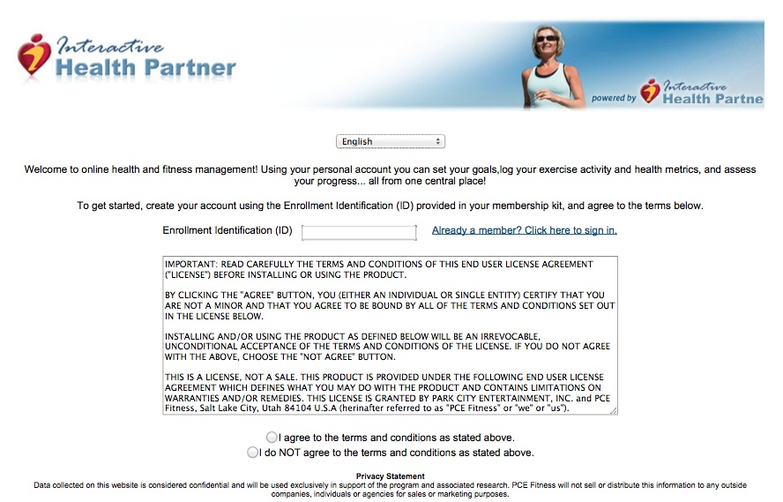
- Enter the Enrollment
ID and continue with
the registration
process.

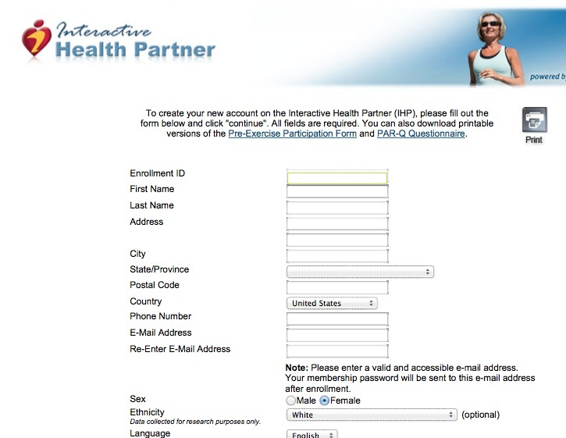
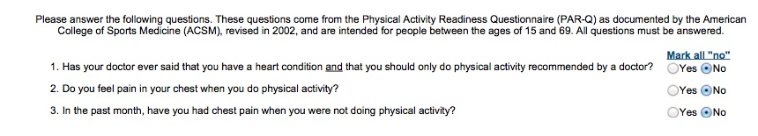
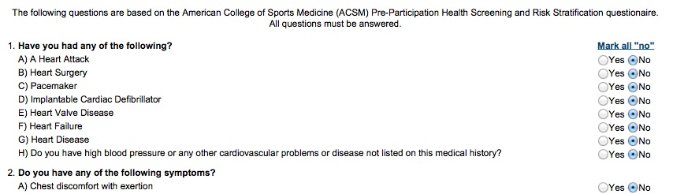

Step 3 – Enter Health Info
- Provide basic contact
information
- Complete Physical Activity Readiness Questionnaire
- Complete health history form

Please Note:
None of your health related data will be shared with anyone.

Step 4 – Confirmation
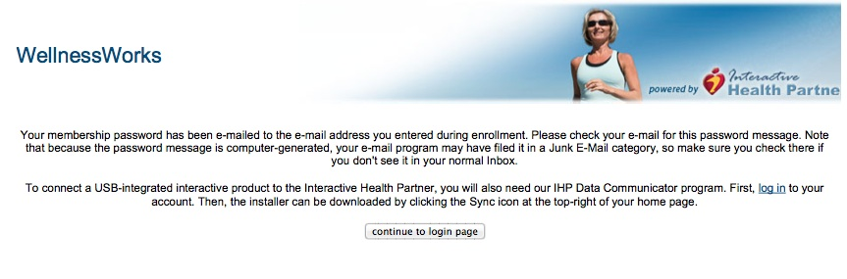
- Check your email to get the PIN number
- Click “Continue” and enter the PIN number

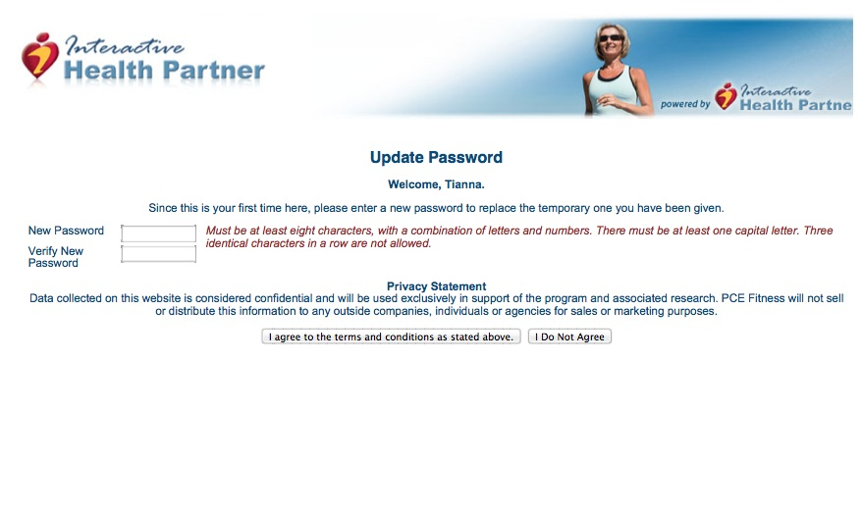
Step 5 – Reset Password
You are now ready to begin using the Interactive Health Partner! When you wish to log in next time remember to go to: https://www.interactivehealthpartner.com and click on the member login. If you have any questions contact the Wellness Works team at wellnessworksisu@gmail.com

The IHP Programming is provided through ‘Wellness Works’, a service learning and outreach program of the Department of Kinesiology at Iowa State University (www.wellnessworksisu.org)

